# MOVISUIT Guide to run 48V SEW Motor

## Device Details

Device type: DCA-DFC2xx-0110-L-T01

Main firmware Part number: 18294383 Version: 10.11 Release: 2023062102

Device Update Manager firmware Part number: 18294324 Version: 10.11 Release: 2023062102

Main FPGA firmware Part number: 18289657 Version: 02.10 Release: 2023053101

Power section configuration data set Part number: 18292097 Version: 01.00 Release: 1

Bootloader Part number: 18286720 Version: 10.11 Release: 2023062102

Main component: Version: In the device: 10.11 In the project: 10.11 Software module: Version: In the device: 10.2.1.200 In the project: 10.2.1.200

Device family: DFC2.A – PROFINET

Firmware 1: Part number: 18263038 Version: 06.00 Release: 2023020101

Firmware 2: Part number: 18263062 Version: 08.00 Release: 2023020101

Version: In the device: 06.00 In the project: 06.00

Hardware variant ID: 1

Production data Serial number: 40.8420004601.0001.24

MOVISUITE® V2.60 (2.60.329.0) —

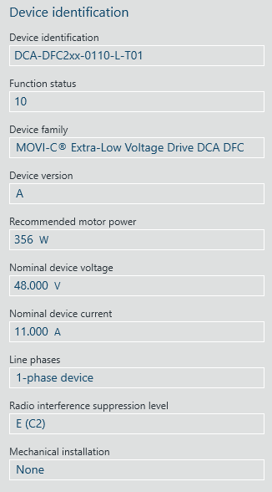

## Running the Motor 48V from the MOVISUIT

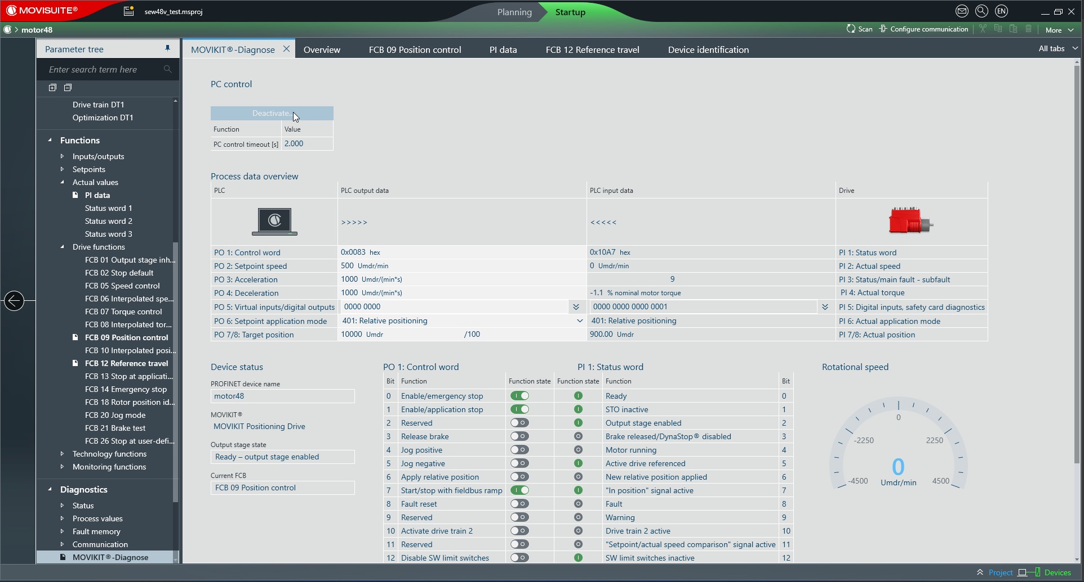

Activate the control from the MOVISUIT Diagnose.

## Useful modes for Running the motor

1. 200 – Speed Control
2. 300 – Reference travel – without parameter - the motor actual position (PI7/8) is set to 0
3. 301 – Reference travel – with parameter - the motor actual position (PI7/8) is set to the target position (PO7/8) as the reference position. This is also called relative referencing.
4. 400 – Absolute Position – Sets the position of the motor to the position set in Target position input
5. 401 – Relative Position – Sets the position of the motor relatively to the current position of the motor (Adding the Target position to the Actual position)

## Common control bits for running the motor

* Control Word 1
  + PO1:0 – Enable emergency stop
  + PO1:1 – Enable application stop
  + PO1:7 – Start/Stop motor
  + PO2 – Setpoint Speed
  + PO3 – Set Acceleration
  + PO4 – Set Deceleration
  + PO6 – Set the application mode
  + PO7/8 - Set Target position

## Controlling the Motor in the position mode and doing calibration

The following are the steps to control the motor in the position mode

1. Make sure that the Type “Referencing without reference travel” is set in the FCB12 Drive function
2. If we want to do “ZERO - 0” referencing which means that the Actual position of the drive is put to 0 then we need to put the Setpoint application ***PO6 to 300*** and turn ON, the following bits PO1:0, PO1:1, PO1:7. Once done then in the feedback PI1:5 becomes TRUE and we can see “0” in the PI7/8 Actual position.
3. If we want to do “Relative” referencing which means that the Actual position of the drive is put to value which we set in the PO7/8 then we need to put the Setpoint application ***PO6 to 301*** and turn ON, the following bits PO1:0, PO1:1, PO1:7. Once done then in the feedback PI1:5 becomes TRUE and we can see Target position value from PO7/8 in the PI7/8 Actual position.
4. Once the calibration is done, we can use the motor in the Absolute and Relative position control modes
5. To run the motor in the absolute position mode then the PO6 should be set to 400. Make sure you have entered the values in the setpoint speed, acceleration, and deceleration. Once done then set the following bits PO1:0, PO1:1, PO1:7 to move the motor.
6. To run the motor in the relative position mode then the PO6 should be set to 401. Make sure you have entered the values in the setpoint speed, acceleration, and deceleration. Once done then set the following bits PO1:0, PO1:1, PO1:6, PO1:7 to move the motor.